Day 2 – JOIN + Aggregation + Analysis
Part 4: JOIN + Aggregation
1. Course title + instructor name + enrollments.
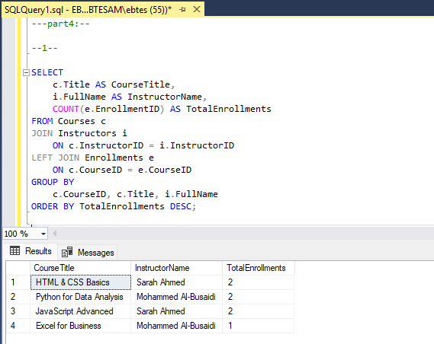
2. Category name + total courses + average price.
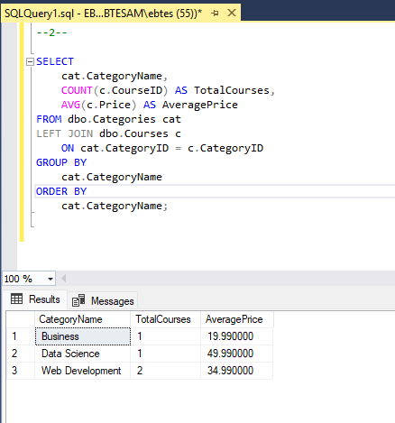

3. Instructor name + average course rating.
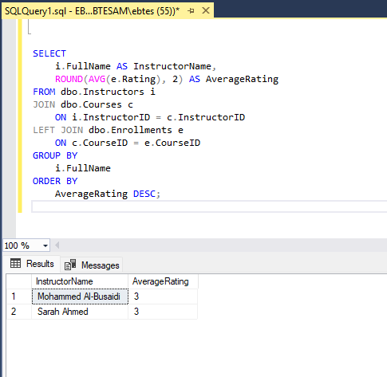

4. Student name + total courses enrolled.
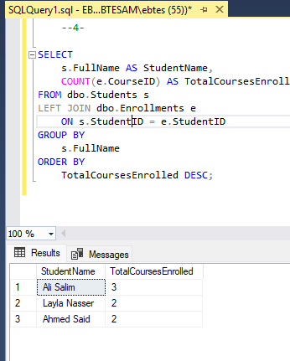

5. Category name + total enrollments.
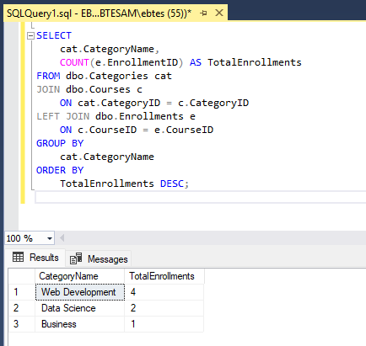

- Instructor name + total revenue.
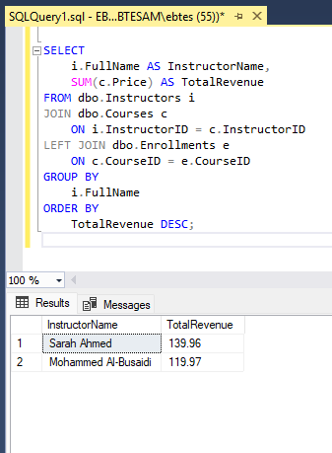

7. Course title + % of students completed 100%.
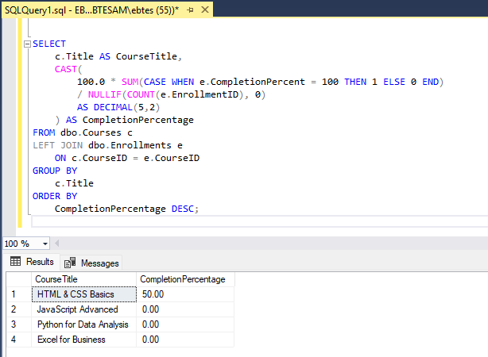

Part 5: HAVING Practice
1. Courses with more than 1 enrollments.
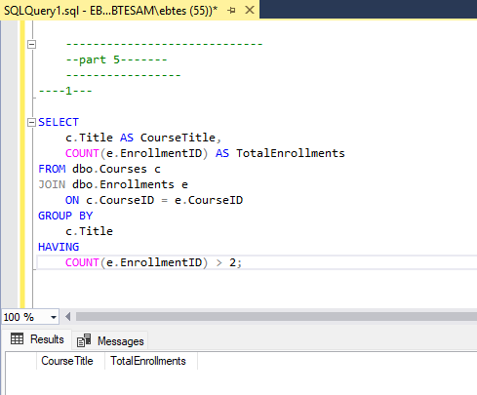

2. Instructors with average rating above 2.
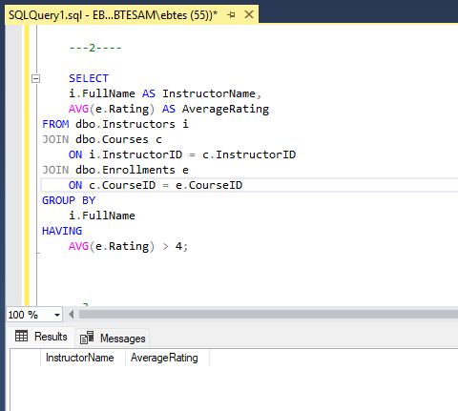
3. Courses with average completion below 60%.
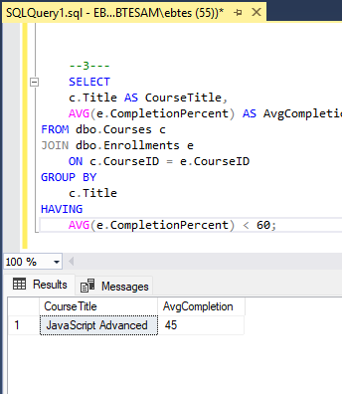

4. Categories with more than 1 course.
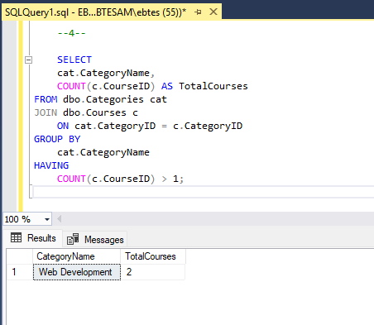
5. Students enrolled in at least 2 courses.
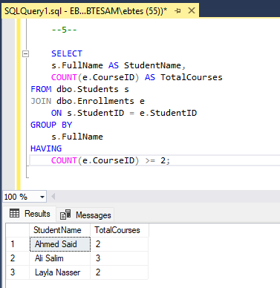
Part 6: Analytical Thinking
Answer using SQL + short explanation:
1. Best performing course.
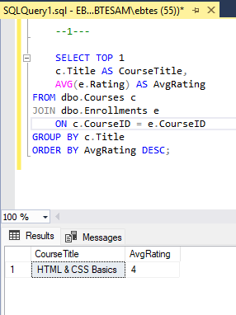
Finds the course with the highest average rating across all enrollments.

2. Instructor to promote.
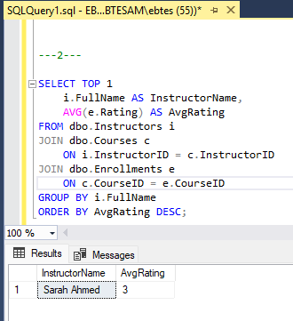
The instructor whose courses have the highest average student rating.

3. Highest revenue category.
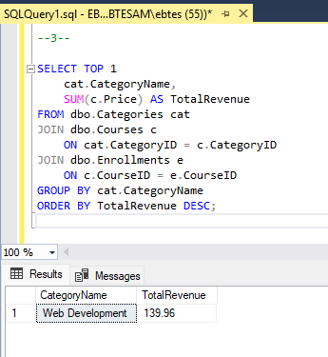
Sums course price × enrollments per category to find the highest revenue.

4. Do expensive courses have better ratings?
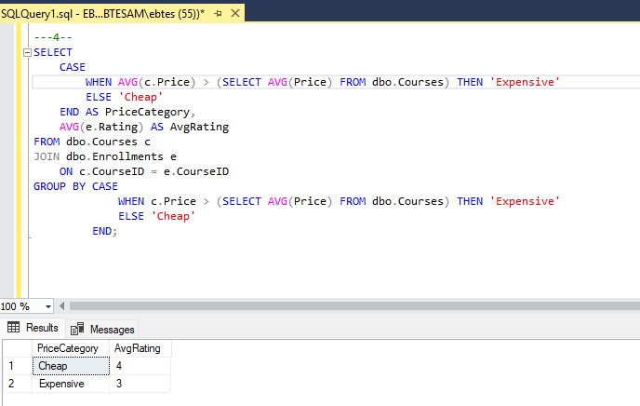
Compares average rating of courses above vs below the overall average price. Shows if expensive courses are rated better.

5. Do cheaper courses have higher completion?
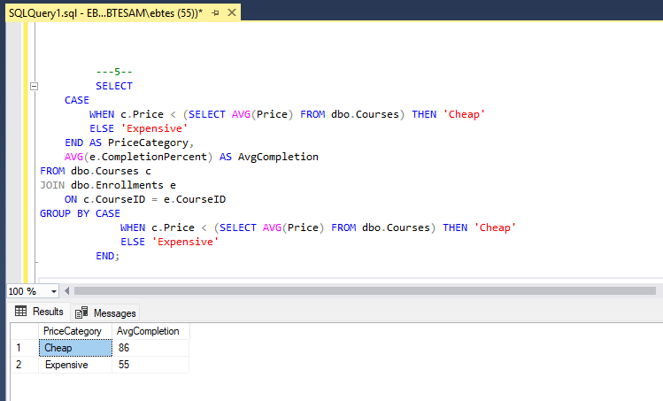

Shows if cheaper courses have higher completion percentages compared to expensive ones.

Final Challenge – Mini Analytics Report
1. Top 3 courses by revenue.
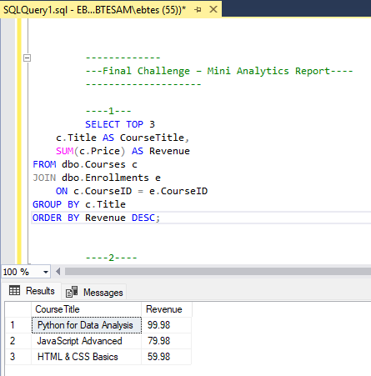

2. Instructor with most enrollments.
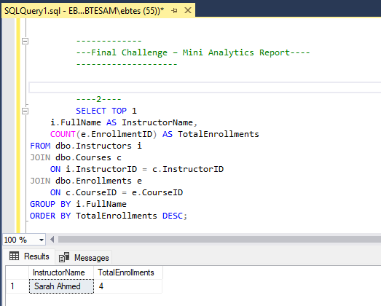
3. Course with lowest completion rate.
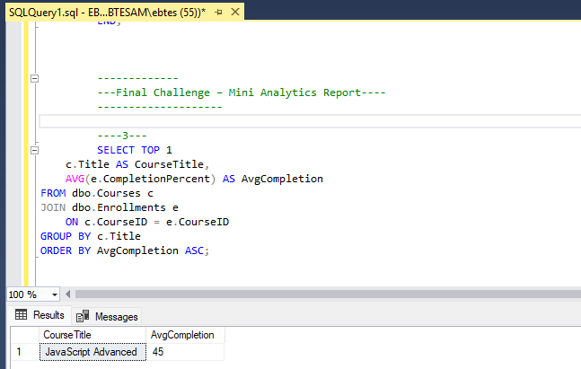
4. Category with highest average rating.
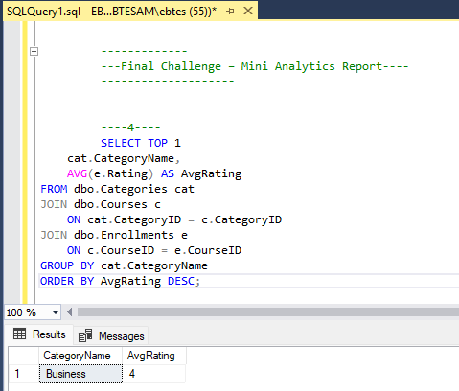

5. Student enrolled in most courses.
